1. Go to System Environment Variables

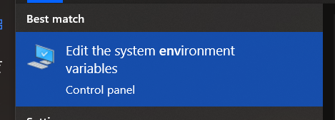

1. Find Path in System Variables and click Edit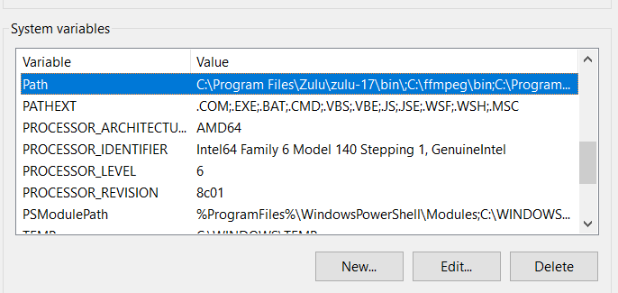
2. Click New and type “C:\Program Files\MySQL\MySQL Workbench 8.0\” without the quotes and click Ok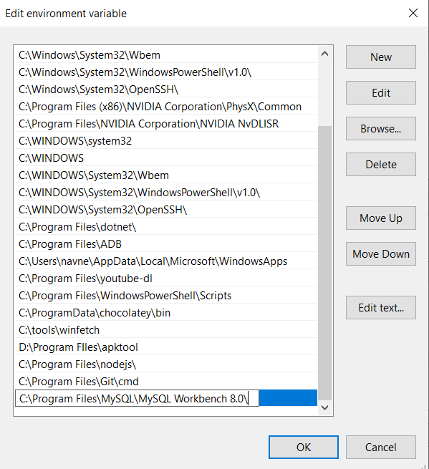
3. Go to CMD and type “mysqldump -uroot -p <db_name> > <file_name.sql>”Text

   Description automatically generated
4. Now on other pc, repeat steps 1-3 and create a database with the same name as the old database you’re importing from
5. Type “mysql -uroot -p <db_name> < <file_name.sql>”Text

   Description automatically generated   
   Notice the change in the arrows here, < instead of >
6. Tada you should be good to go now
7. NOTE: If you get an error like so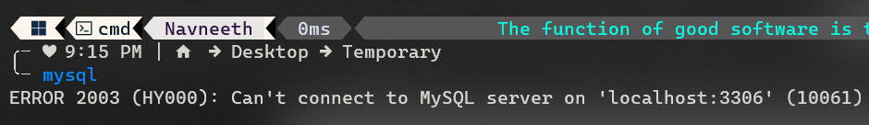  
   then go to CMD prompt as Administrator and type “net start mysql80”, it should start now